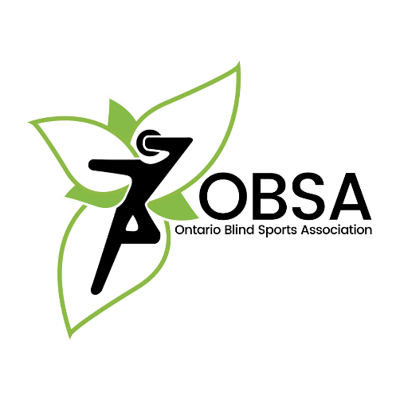
Guide Assistance Program - Application Form

Steps to Apply

- Understand rules and eligibility criteria
- Complete the application form and submit it to us
- Keep your receipts and submit them to us following your trip
- Receive payment by mail

Eligibility Criteria
  - Guide must be a member in good standing with OBSA
  - The athlete working with the guide must be a member in good standing with OBSA
  - The athlete working with the guide must be identified by OBSA as a high-potential athlete
  - The athlete must meet the minimum criteria outlined in Quest for Gold
  - Guides who work with nationally AAP-carded athletes are ineligible

Funding Guidelines
  - Applications should be submitted no later than 1 week prior to the start of a pre- competition camp
  - Funding is only available for out-of-town training camps or competitions
  - Funds are dispersed based on the order in which applications are approved until funds expire.
  - The total amount available to a guide per year is $1000.00 (April 1 – March 31)

Ineligible Expenses
  - Meals
  - Equipment and other gear, apparel
  - Medical expenses including physio, chiropractic or any other related treatment

Guide Runner Information:

Name: | DOB: |  | Gender:
Email: |  | Phone:
Address:
Current Role Within Sport:

Sport Information (Current):

Sport:
Provincial Sport Org:
National Sport Org:
International Sport Org:
Paralympics? Y / N | World Championship? Y / N |  | National Championship? Y / N
Provincial Championship? Y / N |  | Are there any available competitions in Canada? Y / N
Current Clubs, Programs, Camps and Activities (please describe):

Athlete Information:

Name: | DOB: |  | Gender:
Email: |  | Phone:
Address:
Current Role Within Sport:

Request Information:

Please describe how the funds will be utilized:
How will this fund benefit your training:
Please provide any information you wish to add on another page. Thank you for your interest!

